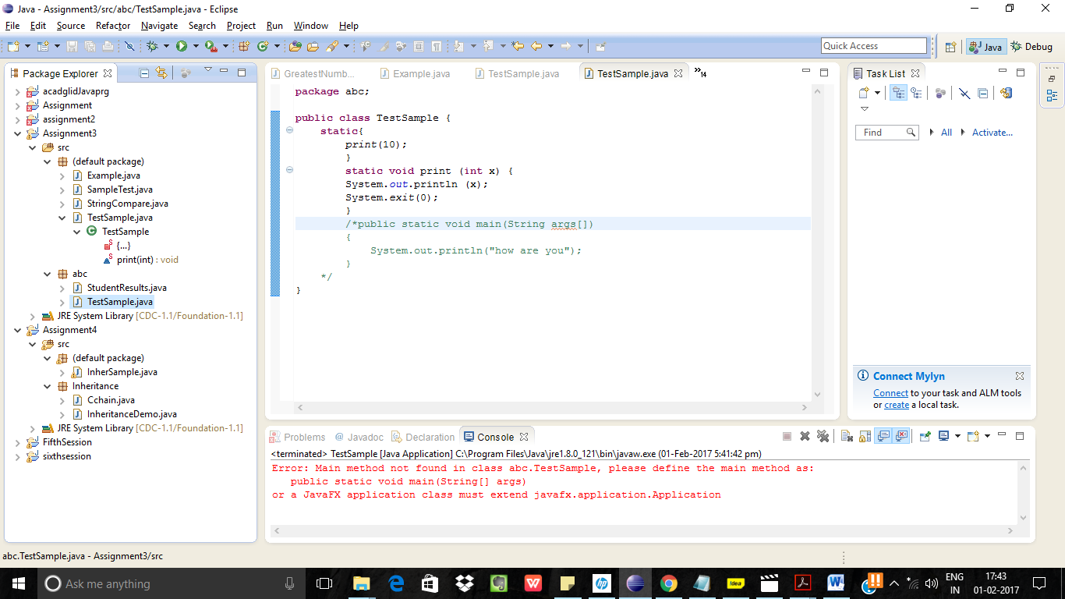

Compilation error stating main class could not be loaded.